The Roles of Chloride in Crop Production  - Photosynthesis and enzyme activation  - Transport of other nutrients in plants  - Water movement in the cell  - Stomatal Operation  - Suppression of plant diseases  - Enhanced disease tolerance of crops  - Reduced late season lodging  - Accelerated plant development  Characteristics of Chloride Sources  - Potassium Chloride: Not used much on high K soils, makes low analysis fluid, limited concentrations in UAN mixes.  - Magnesium Chloride: Available in fluid form BUT cannot have P anywhere in system.  - Ammonium Chloride: high CL concentration, available in fluid form, mixes well with N, P, S, micronutrients. |  |  | Cl Rate (lbs./Acre) Dickinson County Yield (bu/Acre) Clay County, KS Yield (bu/Acre)  0 103 54  10 108 62  20 113 62  30 120 60  Average 111 59.50  2015 Chloride Study  Sorghum Yields  Chloride Fertilization Application Considerations  - CL is very soluble so broadcast applications work well  - Placement with the seed at planting may limit rates due to potential injury from Cl salts  FOR MANY GROWERS, CHLORIDE FERTILIZATION MAY BE THE SOURCES OF THE NEXT BUSHEL OF YIELD AND DOLLAR OF PROFIT!  Abilene Products, Inc.  818 SE 4th  Abilene, KS 67410  Phone: 785.263.3037  Fax: 785.263.1331  Dale Koop: 785.479.3753  Email: dale@abileneproducts.com  Visit us at www.cropservicecenter.com! |  |  | Chloride In Crop Production  - Abilene Products, Inc.

Bump Your Wheat Yields with Chloride  There’s mounting evidence that wheat growers are overlooking a simple, inexpensive crop input called chloride. University research has continually established the importance of chloride in crop production. Research has shown that the application of adequate amounts of chloride can result in:  - Increased kernel and test weights  - Earlier heading and flowering  - Significant yield increases  - Suppression of fungal diseases  - Prevention of late season lodging  Kansas State University  Wheat and Chloride Test Results 2006  Belleville, KS (2145)  Chloride lbs./Acre Bushels/Acre  0 38  10 43  20 45  30 44  40 45  *Yield increases of 7 to 10% in response to chloride is common.  **Yield responses vary among varieties due to application of chloride. |  |  | 2015 Wheat Variety Test  Wheat CL Check  Armour 61.5 44.5  Redhawk 42.5 33.5  Winterhawk 55.5 37.5  Wizard 43.5 48.5  Everest 49.5 43  Endurance 41.5 41.5  Pistol 36 40  1863 48 49  Southwind 49 42  T158 51.5 49  WB 4458 59.5 48.5  Cedar 62 50.5  Hotrod 53 46  Grainfield 54 43  Wolf 50 48.5  Average 50.47 44.33  Dickinson County, KS  The key to profitable chloride use lies in a proper soil test. A soil chloride test is not normally included in routine soil testing reports, it must be requested! Usually a 2 foot soil test is taken to determine soil chloride levels. Critical levels can be adjusted if a 6’2/3” sample has been taken. Soils are considered to be deficient in wheat for chloride when the sample shows 35# or less chloride per acre. The most common rate of chloride applied is 20# per acre. An application of 20#’s of chloride can return an investment of 2 to 3 fold.  Continued on next page…. |  |  | Continued from previous page...  Chloride may be applied before, during or after planting but he easiest way however, would be a liquid top-dress application at the same time nitrogen is applied. Research in Kansas continues to show that wheat responds consistently to chloride fertilization.  Chloride Increases Sorghum Yield, Decreases Lodging  Kansas  Nutrient Rates, lb./A Yield Lodging  N K20 Cl bu/A %  75 80 60 99 1.7  75 80 0 91 6.8  Silt loam soil, low soil test K  KSU Soil test chloride: unknown  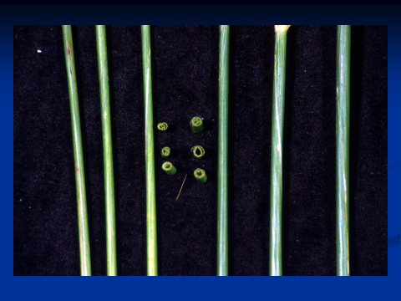  Proper chloride fertilization also can reduce lodging, which occurs when harvest is delayed by rain or other factors. Retention of water in the plant and delayed maturity may be reasons for such a response.

